EXP:3 | Setting Up Hybrid Cloud Connectivity Using Cisco Packet Tracer
22/7/2026
AIM
To simulate a secure hybrid cloud connection between an on-premises data center and a cloud network using routers, switches, subnets, and routing in Cisco Packet Tracer.
SOFTWARE / COMPONENTS REQUIRED
- Cisco Packet Tracer
- Two Cisco 2911 routers
- Two Cisco 2960-24TT switches
- One PC
- One Server
- Copper Straight-Through cables
- Copper Cross-Over cable for the router-to-router link
NETWORK TOPOLOGY
The simulated network consists of an on-premises LAN connected to a cloud/server LAN through two routers. Static routing is used between the two networks.
PC0 | → | Switch0 | → | Router1
Router1 | → | 10.10.10.0/30 | → | Router2
Router2 | → | Switch1 | → | Server0
PC Network | → | 192.168.1.0/24
Server Network | → | 10.0.0.0/24
IP ADDRESSING TABLE
Device | Interface | IP Address | Subnet Mask | Purpose
Router1 | GigabitEthernet0/0 | 192.168.1.1 | 255.255.255.0 | On-premises  LAN gateway
Router1 | GigabitEthernet0/1 | 10.10.10.1 | 255.255.255.252 | Router-torouter link
Router2 | GigabitEthernet0/0 | 10.0.0.1 | 255.255.255.0 | Cloud LAN gateway
Router2 | GigabitEthernet0/1 | 10.10.10.2 | 255.255.255.252 | Router-torouter link
PC0 | FastEthernet0 | 192.168.1.10 | 255.255.255.0 | On-premises host
Server0 | FastEthernet0 | 10.0.0.10 | 255.255.255.0 | Cloud server
CS23633 1 231801014

PROCEDURE
- Open Cisco Packet Tracer and create a new logical workspace.
- Place two 2911 routers, two 2960 switches, one PC and one Server.
- Connect PC0 to Switch0 and Switch0 to Router1 using Copper Straight-Through cables.
- Connect Server0 to Switch1 and Switch1 to Router2 using Copper Straight-Through cables.
- Connect Router1 GigabitEthernet0/1 to Router2 GigabitEthernet0/1 using a Copper CrossOver cable.
- Open Router1 CLI. When prompted for the initial configuration dialog, enter no and press Enter.
- Configure Router1's LAN and inter-router interfaces.
- Verify Router1 interfaces using show ip interface brief.
- Open Router2 CLI and configure its LAN and inter-router interfaces.
- Configure PC0 with IP address 192.168.1.10, subnet mask 255.255.255.0 and default gateway 192.168.1.1.
- Configure Server0 with IP address 10.0.0.10, subnet mask 255.255.255.0 and default gateway 10.0.0.1.
- Configure static routes on both routers so that the two LANs can communicate.
- Verify the routing tables using show ip route.
- From PC0, use ping 10.0.0.10 to verify end-to-end connectivity.
- Save the router configurations using copy running-config startup-config.
ROUTER CONFIGURATION COMMANDS
Router1 Configuration
enable configure terminal interface gigabitEthernet0/0 ip address 192.168.1.1 255.255.255.0 no shutdown exit interface gigabitEthernet0/1 ip address 10.10.10.1 255.255.255.252 no shutdown exit ip route 10.0.0.0 255.255.255.0 10.10.10.2 exit
copy running-config startup-config
Router2 Configuration
enable configure terminal interface gigabitEthernet0/0 ip address 10.0.0.1 255.255.255.0 no shutdown exit
CS23633 2 231801014

interface gigabitEthernet0/1 ip address 10.10.10.2 255.255.255.252 no shutdown exit ip route 192.168.1.0 255.255.255.0 10.10.10.1 exit  copy running-config startup-config  Verification Commands  do show ip interface brief show ip route ping 10.0.0.10  OUTPUT / OBSERVATION  The following outputs were obtained during the simulation.  Router1 Interface Verification  Interface IP-Address Status Protocol  GigabitEthernet0/0 192.168.1.1 up up  GigabitEthernet0/1 10.10.10.1 up up  GigabitEthernet0/2 unassigned administratively down down  Vlan1 unassigned administratively down down  Router2 Interface Verification  Interface IP-Address Status Protocol  GigabitEthernet0/0 10.0.0.1 up up  GigabitEthernet0/1 10.10.10.2 up up  GigabitEthernet0/2 unassigned administratively down down  Vlan1 unassigned administratively down down  Router1 Routing Table – Static Route  S 10.0.0.0/24 [1/0] via 10.10.10.2  C 10.10.10.0/30 is directly connected, GigabitEthernet0/1  L 10.10.10.1/32 is directly connected, GigabitEthernet0/1  C 192.168.1.0/24 is directly connected, GigabitEthernet0/0  L 192.168.1.1/32 is directly connected, GigabitEthernet0/0  Router2 Routing Table – Static Route  C 10.0.0.0/24 is directly connected, GigabitEthernet0/0  L 10.0.0.1/32 is directly connected, GigabitEthernet0/0  C 10.10.10.0/30 is directly connected, GigabitEthernet0/1  L 10.10.10.2/32 is directly connected, GigabitEthernet0/1 S 192.168.1.0/24 [1/0] via 10.10.10.1  Connectivity Test  C:\>ping 10.0.0.10  Pinging 10.0.0.10 with 32 bytes of data:  Reply from 10.0.0.10: bytes=32 time<1ms TTL=126  Reply from 10.0.0.10: bytes=32 time<1ms TTL=126  Reply from 10.0.0.10: bytes=32 time<1ms TTL=126 Reply from 10.0.0.10: bytes=32 time<1ms TTL=126  CS23633 3 | 231801014
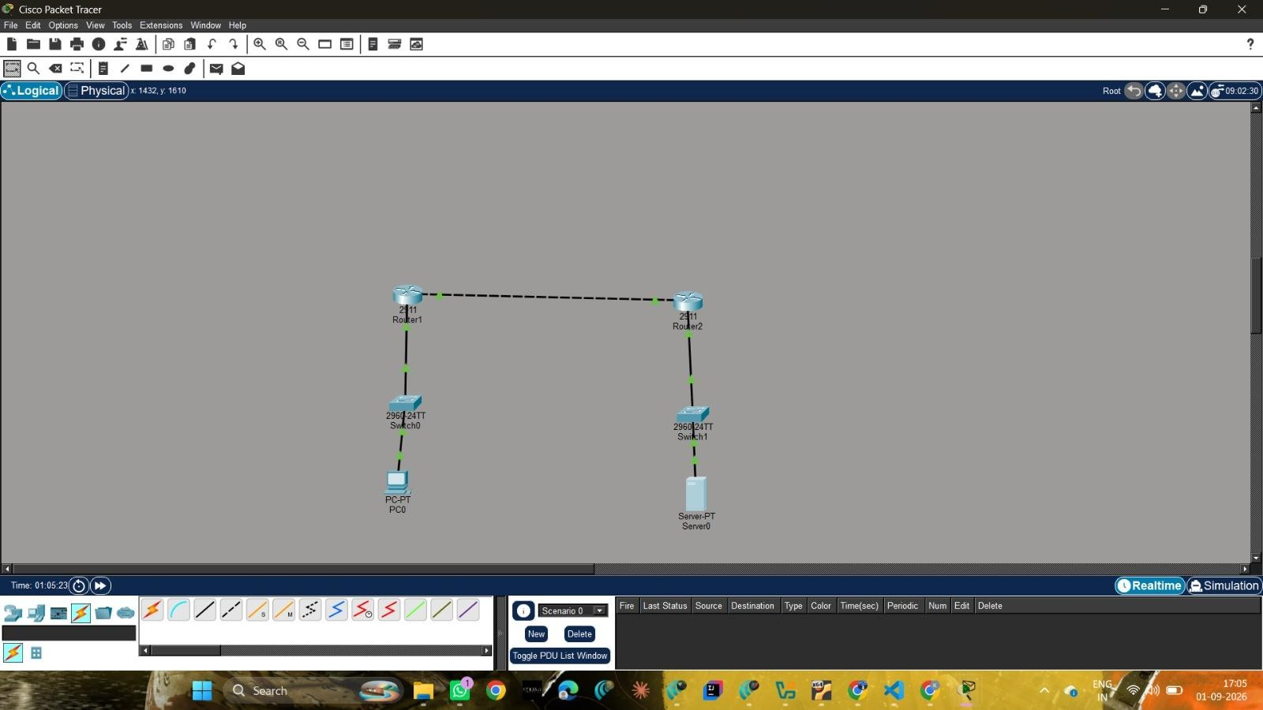

CS23633

4

231801014

Ping statistics for 10.0.0.10:

Packets: Sent = 4, Received = 4, Lost = 0 (0% loss)

Minimum = 0ms, Maximum = 1ms, Average = 0ms

CONCLUSION

The experiment demonstrated the configuration of a basic hybrid cloud connectivity scenario
using routers, switches, an end device and a server. Static routes enabled traffic to travel
between the 192.168.1.0/24 and 10.0.0.0/24 networks.

